Oh How He Suffers
November 22nd, 2021

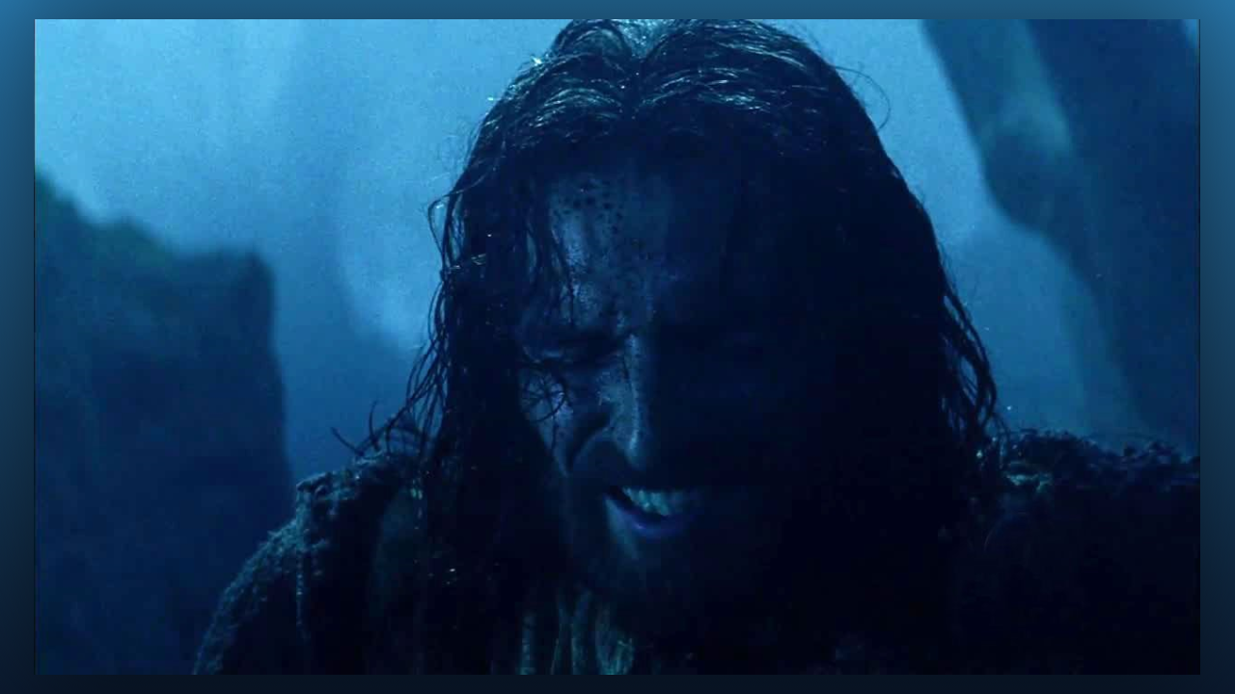
Lord, grant us Your strength, that we may not give up even when the trials increase. Help us to focus on You and not on ourselves or our problems, because we know that with You, God, all things are possible. Amen.

“Oh Mother it is just too terrible what is happening around the world!”

Mother Mary began, “You should see the face of my Son. It is beyond recognition in grief. There are not words for the torments He is suffering through in the hopes that situations will be gracefully resolved. But some people are so overtaken with the hatred of Satan, they in no way are thinking about anyone.

“For many it would be better if they had never been born. He feels everything very acutely Clare. This would be a good time to comfort Him. He has been living with these things for months as they continue to worsen. His whole body was covered with deep wounds.

“There is no end to His suffering, because there is no end to the suffering of mankind in this hour. And yet, He is willing to suffer still more for the sake of the lost. No one can understand the suffering of Our God, it is simply beyond comprehension, and yet He perseveres in this for the sake of the few that might be saved. Is it so great a thing in the face of this to join your sufferings to His? Is it too much to ask?”

“Certainly not. I am sorry I am so weak in suffering. How wonderful it must be for those who can bear with torments.”

“Yes, you have seen that in your husband, oh Clare if only you could get but a taste, you would understand so much more. You have been placed in the safety of this place where you are surrounded with those who love you. There is also great protection. I want you all to know that each of you bring Him comfort in what He must suffer. I know it seems like only a little thing to carry your own crosses willingly, but it is not, the merits of doing that are many and will never be forgotten.” “It is finished” …even though He said that, it will never finish until Satan is no more and all hearts of mankind are restored.”

